Title of your paper to be presented in the 10th ISMTMF-Hong Kong

Huihe Qiu and Zhenlan Xue
Department of Mechanical and Aerospace Engineering
The Hong Kong University of Science & Technology
Clear Water Bay, Kowloon, Hong Kong
E-mail: ismtmf@ust.hk

Abstract
Your abstract should be in one-page and is used for classification of your topic to suitable techical sessions planned in the ISMTMF. The abstract will NOT appear in the proceedings, and the author of accepted abstract will be requested to submit extended abstract later, which will be printed in the proceedings to be distributed as a book of extended abstracts in the ISMTMF.
The preferred style of this abstract for easy review, Abstract should be A4 size (210cm by 297cm) and the margins are, Top2.5 cm, Bottom 2.5cm, Left 2.5cm, Right 2.5cm in single column. Main body text is 11pt Times New Roman.
For easier assesment of your work by the scientic committee members, the abstract must be very concise and informative. Please show the most representative figure(s) in this abstract such as experimental setup and typical result of measurement (see Figure 1). Also, please give several keywords at the bottom of the page. In the step of the abstract submission, number of words and fonts do not matter but the abstract must be printable in one-page.
After the prepation of the abstract, please send it to the following e-mail address by attaching as pdf or doc file to: ismtmf@ust.hk (Symposium Secretariat, ISMTMF2017).
In the case of any specific inquiry, please send your e-mail to Prof. Huihe Qiu, by e-mail: meqiu@ust.hk or by phone: +852(Hong Kong)-23587190 or by Fax to +852(Hong Kong)-23587190.

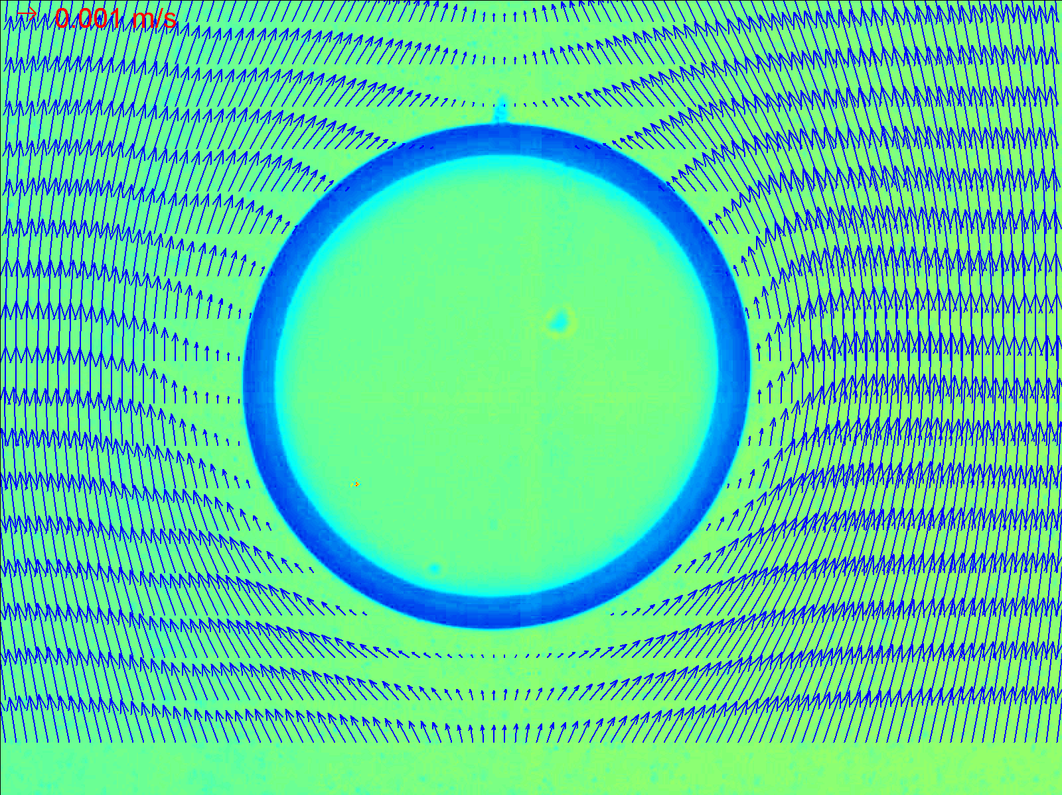
Figure 1 Micro PIV measurement results of velocity field around a bubble

Keywords
Particle image velocimetry, Bubble Dynamics Visualization, Molecular tagging velocimetry, Multiphase flowmeter, Multiphase rheometer

